Assess and Implement Machine Learning Algorithm to Predict Intrusion in Network.
Anshuman Dey Kirty¹, Mayank Agarwal², Tannishtha Das³, Dr. Kakelli Anil Kumar⁴
^{1, 2, 3} SCOPE, VIT University, Vellore, India
¹anshumandey.kirty2015@vit.ac.in, ²mayankagarwal.2015@vit.ac.in, ³tannishtha.das2015@vit.ac.in
⁴Associate Professor, SCOPE, VIT University, Vellore, TN, India
anilkumar@vit.ac.in

Abstract— The need to secure networks has increased as the number of people connecting to the network are increasing rapidly and using networks for storing or accessing critical information. In this paper we have assessed and compared various machine learning algorithm and then propose a system based on the best performing algorithm. Our system is an intrusion prediction system with low error rate and can be implemented in real world. The dataset used in this project would be the database that contains set of data to be assessed, which includes a wide variety of intrusions simulated in a military network environment. The dataset contains mainly the normal state, DDoS based SMURF attack, teardrop attack, rootkit, multihop, Neptune attack and few other attacks. The system will not only predict a malicious network but also point to exactly under which type of attack the network is subjected to.
Key words: more than four key words must be given.
- Introduction
With the advancement in the technology, millions of people are now connected with each other through one or other form of network where they share lots of important data. Hence the need of security to safeguard data integrity and confidentiality is increased rapidly. Although effort have been made to secure data transmission but at the same time, attack technique for breaching the network continued to evolve. Thus it leads to the need of such a system which can adapt with this ever changing attack techniques. In this paper, we have purposed a system which is based on machine learning. Our aim is to find the based suitable machine learning algorithm which can predict the type of network attack with highest accuracy and then develop a system which uses this algorithm to detect network intrusion. The algorithms which we have compared are Naïve Bayes, Decision Table, K Nearest Neighbor, Random Forest and Adaboost. The dataset used for training the model is KDD 99 dataset. The reason why we have used machine learning is the flexibility that it provides to the system for example, if any new type of attack is developed in future the system can be trained for predicting that attack. There are a few types of intrusion detection system out of which ours is a knowledge based intrusion detection system which is also known as the anomaly based system. It registers the anomalies and in future predicts such malicious network to send out an alert. This way the network can disconnect to the such a connection and then have only secured connections.
- Literature Survey
In [1], Rafath and D Vasumathi, classified the intrusion detection system into two types namely Network based IDS and Host IDS. The latter monitors all the activities of inspected packets and resources that are being utilized by the programs. In case of any alteration in networks the user gets a network alert. HIDS is incorporated into the computer framework to detect the abnormalities and protect the information from the intruder. On the other hand, NIDS is the attribute function of target system. It uses anti-thread software to control incoming and outgoing threads. It consists of signature based classification, which help in identifying the abnormalities by comparing it with log files and previous signature.
In [2], the authors proposed an AI based Intrusion detection system using a deep neural networks. Neural networks consisting of four hidden layers and 100 hidden units was used for the intrusion detection system. They used non-linear ReLU as the activation function for the hidden layer neurons to enhance the model’s performance. They adopt stochastic optimization method for learning in DNN. For the training and testing of their model they used KDD CUP 99 dataset. They were able to reach the accuracy of 99% for all the cases.
In [3], they have proposed a NIDS (Network Intrusion Detection System) which is based on a feature selection method called Recursive Feature Addition (RFA) and bigram technique. They tested the model on the ISCX 2012 data set. Moreover, they have proposed a bigram technique to encode payload string features into a useful representation that can be used in feature selection. They have also proposed a new evaluation metric called that combines accuracy, detection rate and false alarm rate in a way that helps in comparing different systems and selecting the best among them.
In [4], they have proposed a new intrusion detection system and addressed the problem of adaptability in the field of intrusion detection. The proposed IDS is an adaptive solution which provides the capability of detecting known and novel attacks as well as being updated according to the new input from human experts in a cost-effective manner.
[5], deals with the evaluation and statistical analysis of labelled flow based CIDDS-001 dataset used for evaluating Anomaly based (NIDS) Network Intrusion Detection Systems. They basically used two techniques, k-means clustering and k-nearest neighbour classification to measure the complexity in terms of prominent metrics. On the basis of evaluation, they concluded that both k-means clustering k-nearest neighbor classification perform well over CIDDS-001 dataset in terms of used prominent metrics. Hence the dataset can be used for the evaluation of Anomaly based Network Intrusion Detection Systems.

- Algorithms overview
- Naïve Bayes Classifier
It uses Bayes theorem to calculate the membership probability of an instance for a particular class. The Instance is then assigned to the class for which it is having the highest probability. Naïve Bayes assumes that all the features are independent of each other i.e. presence or absence of any feature will not affect the presence or absence of any other feature.
- Decision Table
- K Nearest Neighbor
- Random Forest
Random Forest algorithm is a classification algorithm based on ensemble learning. It works by building multiple decision trees at training and the developed decision trees forms the output function.
- AdaBoost
Adaboost is an ensemble method which creates a strong classifier from a number of weak classifiers. It can be used with any machine learning algorithm to boost its performance however it is generally used with decision tree. It adds many weak learners sequentially until a preset number of weak learners have been created or no further improvement in performance can achieved on the training dataset.

- Proposed System
The dataset taken from the Kdd99 is a huge dataset and the one that we have used in our research is under the folder corrected. Our aim is to not only to find the best algorithm suited for the intrusion detection but also to implement it using the programming language R. The first process of applying learning is to pre-process the data. First, we convert the files to CSV format. Then we have to remove the redundant rows from the dataset. Then our next step is to see whether there are any missing values and then to remove those corresponding rows too.
The next process is to use this dataset and put it across various machine-learning algorithms that might give good results by correctly classifying the instances. The tool that we used is the Weka. Weka is an open source Java platform for processing, classifying, clustering and visualization. It is considered as one of the better data mining tools and therefore we have used it. Steps involved in using Weka are
- Importing the dataset
- Classifying and choosing the algorithm.
- Using the 10 Fold method
- Again testing using the Percentage Split (70%)
- Checking the Correctly Classified Instance Percentage.
The values are observed and tabulated shown in the Results below.
It can clearly be seen from the above give values that the best algorithm that can be used for the network intrusion detection is the Random Forest. Random Forest algorithm is a classification algorithm based on ensemble learning. It works by building multiple decision trees at training and the developed decision trees forms the output function.
The algorithm is elected and now the implementation using the R programming language is to be done. The drawback of this intensive and the accurate algorithm in this case is that the computation time is very high. To lessen the computational time we use feature selection algorithm. The feature selection algorithm used is the InfoGainAttribute using the Weka tool. Information gain is a feature selection method uses entropy of the class variable and then assess the feature.
Using this method, we expect no considerable drop in accuracy in terms of the percentage of correctly classified classes and a great reduction in time taken to detect intrusion in the network. This makes the system for intrusion detection more efficient.
The attributes elected are used in the R program to predict the error rate and in future to predict if a network is bad or normal. This program when developed fully will act as a filter to determine if a network is secure and will continuously learn from its own series of data making it better and stronger with each type of attack.

- Results
Table 1: The results from the Weka are shown in the table.
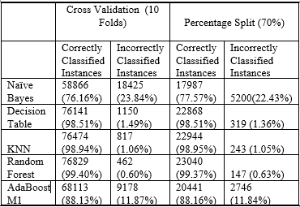

The Random Forest, KNN and the Decision Table give high accuracy but the accuracy achieved in case of the Random Forest is the highest. Therefore, to further our project we choose the Random Forest algorithm, use it practically to find out the error rate using the R Programming language.

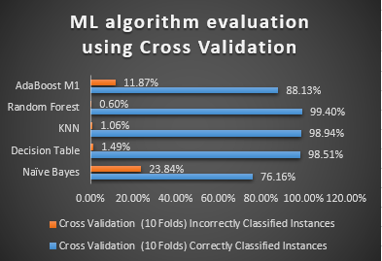
Figure 1 Algorithm Evaluation Graph
The graph in Figure 1 shows that the accuracy for the Random Forest algorithm is 99.40%, the highest. It has been evaluated using the 10 Fold Cross Validation method. In this method the dataset for training is divided into 10 parts and for each part the other 9 parts acts as the training set and the 1 part as the testing set. Average of all such sets gives the 10 Fold validation.

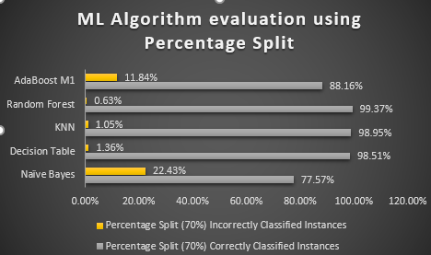
Figure 2 Algorithm Evaluation Graph
The graph in Figure 2 shows that the accuracy for the Random Forest algorithm is 99.37%, the highest. It has been evaluated using the Percentage split (70) method. In this method the dataset for training is divided 70 percent for training purpose and the other 30 percent for the testing purpose.
Before directly using all the 41 attributes onto the R we do feature selection to select the attributes using the InfoGain method to reduce the time of computation whereas the accuracy is not much compromised. The attributes elected are
- SrcBytes - number of data bytes from source to destination
- DstBytes - number of data bytes from destination to source
- DstHostSameSrvRate – Destination host same server rate.
- Count - number of connections to the same host as the current connection in the past two seconds
- DstHostDiffSrvRate - Destination host different server rate.
The number of attributes reduce from 41 to 5 using the InfoGain method which makes it much faster in terms of execution time.
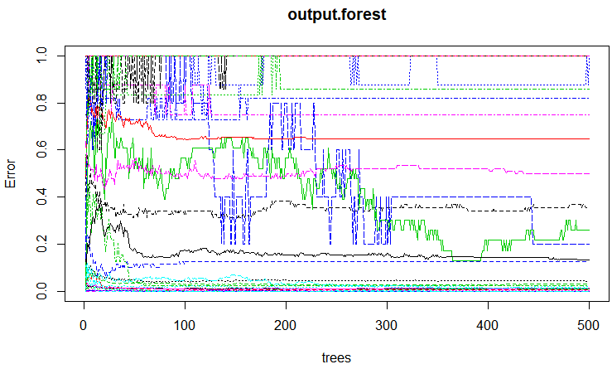
Figure 3 R Output Model Graph (RF)

The R language is then used to see the OOB Estimate of Error that is retrieved after using the Random Forest machine-learning algorithm. The OOB Estimate of Error was found to be 1.46% when the half of dataset was used in training and the other half in testing the algorithm. For each of the testing dataset we can predict if the connection setup is normal or malicious and even pin point to the particular type of attack (example – Neptune, smurf, Saturn, teardrop, rootkit etc.) This means that we can be 98.54% sure of the prediction value shown by the algorithm running on R.

- Conclusion
For network intrusion, prediction the algorithm that can used is Random Forest as shown by the experiment. It gives a high accuracy rate in determining the classes correctly. The process of attribute or feature selection is a very important as it increases the efficiency of the system as a whole during implementation. The loss in percentage of correctly classified instances due to feature selection is not considerable. The method of using the InfoGain feature selection for dataset with many features can be used when machine-learning algorithm like Random Forest is used.
For future studies, this algorithm can be applied to various other real time original data and its accuracy and be continuously monitored. We expect the fully developed system made using this would be of great success in the real world in predicting if the connection set up is normal or malicious. Based on which the further precautions can be taken for secured network.

- References
[1] Review on Anomaly based Network Intrusion Detection System Rafath Samrin Computer Science and Engineering ISL Engineering College Hyderabad, India D Vasumathi Computer Science and Engineering JNTUH Hyderabad, India.
[2] Method of Intrusion Detection using Deep Neural Network by Jin Kim, Nara Shin, Seung Yeon Jo and Sang Hyun Kim.
[3] Network intrusion detection system based on recursive feature addition and bigram technique.
[4] Adaptive and online network intrusion detection system using clustering and Extreme Learning Machines.
[5] Statistical analysis of CIDDS-001 dataset for Network Intrusion Detection Systems using Distance-based Machine Learning.

